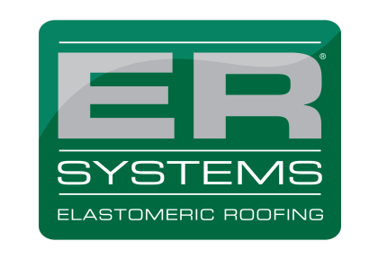
111 South Nursery Road
Irving, TX 75060
800.403.7747- or- 763.565.6900 fax: 763.565.6901
ersystems.com

Warranted Job Completion Form

A Completion Form must be completed and Submitted to ITW Polymers Sealants North America, Inc (“ITW PSNA”, a subsidiary of Illinois Tool Works, Inc) Warranty Department. Upon receipt by ITW PSNA, an inspection will be scheduled. Once all requirements are met and approved, a warranty will be processed and mailed to the Applicator.

Name of Building: Click here to enter text.

Address of Building: Click here to enter text.

City: Click here to enter text. State: Click here to enter text. Zip: Click here to enter text.

Applicator: Click here to enter text.Telephone: Click here to enter text.

Distributor: Click here to enter text. Date of Material Purchase: Click here to enter text.

Distributor Invoice #: Click here to enter text. (Attach copy of Invoice)

Actual Date Project Began:Click here to enter text.Project Completion Date: Click here to enter text.

The following are required to be received by ITW PSNA prior to issuance of any warranties:

• Project Inspection Report/with Photos

Comments: Click here to enter text.

Please find this submittal as confirmation that the above job has been completed according To the Guidelines of the Project. To be warrantable, all roof installations must be made in complete compliance with ITW PSNA WRITTEN Sample design guidelines. I certify that this project was installed according to ITW PSNA written sample design guidelines. The undersigned understands and agrees that issuance of the warranty applied for is subject to receipt, review and approval of all required documents, inspection reports, materials and fees by ITW PSNA Warranty Department.

_______________________________________________________________________
Applicator Signature Date

